William Huck

Zeke Marcel

Hayden Migliore

Project 1

Progress Report

William Huck

Zeke Marcel

Hayden Migliore

CMEN 432

12/20/16

Project 1

Progress Report

William Huck

Zeke Marcel

Hayden Migliore

CMEN 432

12/20/16

FLuidized Catalytic Craker

CMEN 432

4/10/2017

**Introduction**

The oil refining process is a multistep process. An important component in the refining of crude oil into gasoline is the FCC, fluidized catalytic cracker. An FCC is comprised of three components, the reactor, the regenerator, and the fractionator. The reactor takes the feedstock, typically heavy and vacuum gas oils from earlier in the refinery, and uses a catalyst to convert these heavy hydrocarbons into lighter hydrocarbons. As the cracking reaction occurs, carbon coke, a byproduct of cracking, is deposited on the catalyst. This coke reduces the available surface area of the catalyst. To account for coke formation, the regenerator is needed. Spent catalyst is fed from the reactor into the regenerator. Inside the regenerator, steam and air are used to promote a combustion reaction to remove the coke from the catalyst. After it leaves the regenerator, the recycled catalyst is mixed into the fresh catalyst feed into the reactor. The feed into the reactor is vaporized and the products of the reactions are vapors. These vapors are fed to the fractionator. The fractionator is a distillation tower that separates the reaction products into cuts. These cuts are determined by boiling points and are chosen based on the desired products of the process.

**Base Case**

*Process Description*

The feed into the system is VGO. The VGO is fed into a PFR. This PFR operates from 490 to 550oC and 2 to 5 second residence time. Inside the PFR the VGO feed is cracked into LCO, Gasoline, LPG and dry gases through the use of zeolite catalyst. As the cracking occurs, solid carbon coke is formed on the catalyst. This coked catalyst is separated from the product feed by a cyclone separator. The catalyst stream is then feed into a regenerator. Inside this regenerator, incomplete combustion removes the coke from the catalyst creating both heat and a flue gas. The heat generated is carried by the catalyst into the reactor via a recycle stream between the two units. The product stream of the reactor is fed a fractionator unit. The fractionator unit consists of a main distillation column and two secondary column which are fed with side streams from the main tower. The bottoms streams of both secondary towers are recycled into the main tower. A portion of the bottoms stream of the main tower is recycled back into the fresh feed to the reactor. The distillate stream of all three towers as well as a portion of the bottoms stream of the main tower will be sold.

Figure #: Process Overview of FCC Unit

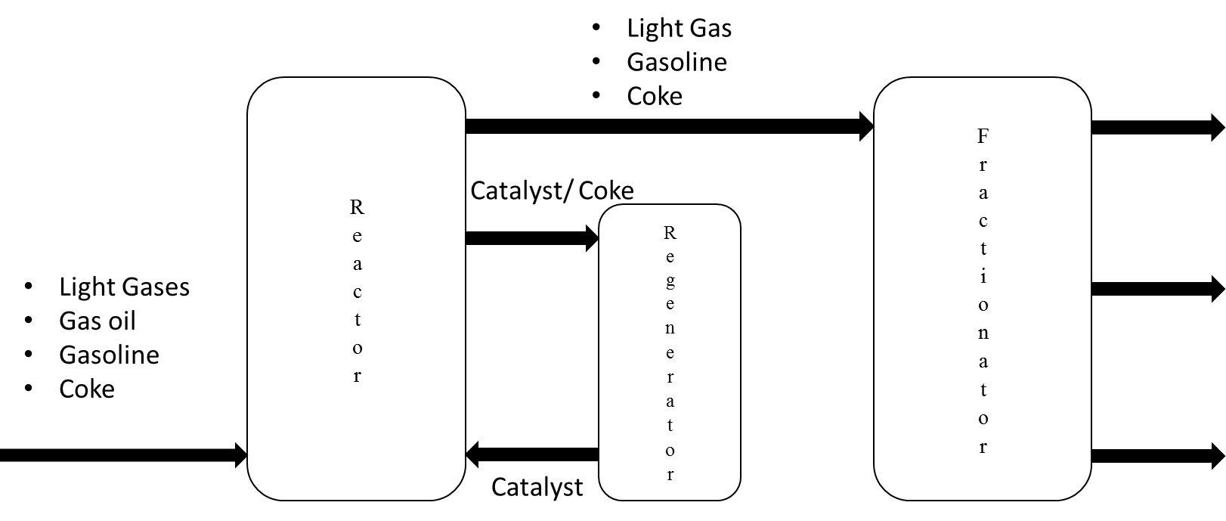

Figure 1: FCC Unit P&ID

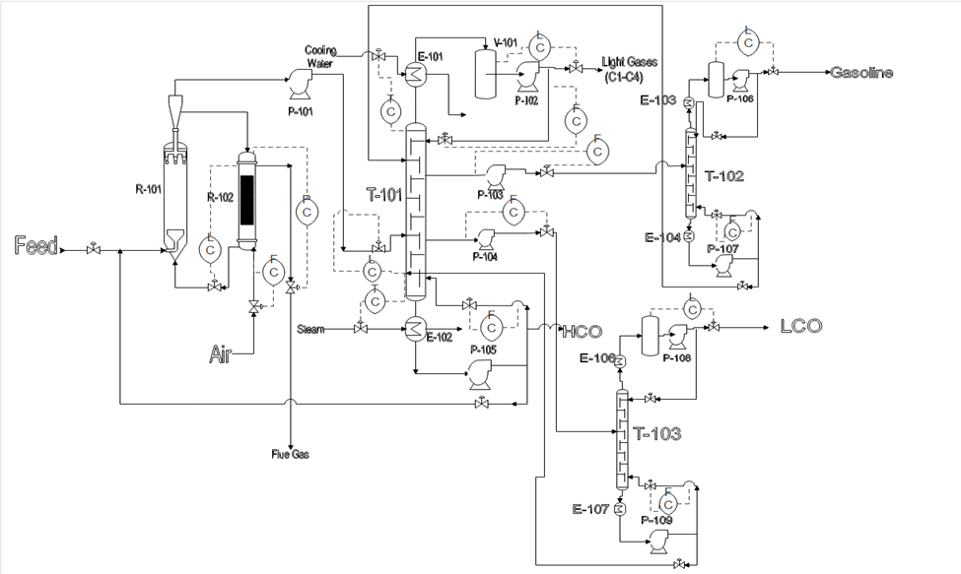

The Best Case is 3 second residence time at 950 °F with a Net Present Value of $417 million**.**

The Net Present Value was found by using the same method as last quarter. The steps for each tower were repeated, and the new components were added. The reactor, regenerator, and cyclone separator were treated as production vessels. The furnace was a non-reacting fired heater. The heat exchanger before the towers is a floating head heat exchanger. The same equation was used to find the NPV as last quarter. The price of each product is listed below.

Table 1:

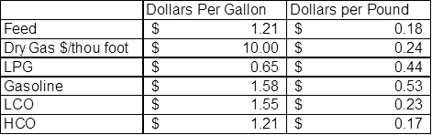

*References*

1. Fluid Catalytic Cracking with Zeolite Catalysts, Paul B. Venuto and E. Thomas Habib, Jr., 1979
2. Sadeghbeigi, R. (2012). Fluid catalytic cracking handbook. [electronic resource] : an expert guide to the practical operation, design, and optimization of FCC units. Oxford : Butterworth-Heinemann, 2012
3. Matar, Sami, and Lewis F. Hatch. Chemistry Of Petrochemical Processes. [Electronic Resource]. n.p.: Boston : Gulf Professional Pub., c2001., 2001. Louisiana Tech University. Web. 12 Dec. 2016
4. Meyers, R. A. (1997). *Handbook of petroleum refining processes*. New York : McGraw-Hill, c1997.
5. Meyers, Robert A. Handbook Of Petroleum Refining Processes. n.p.: New York : McGraw-Hill, c1997., 1997. Louisiana Tech University. Web. 12 Dec. 2016.
6. Bradley, Howard B. Petroleum Engineering Handbook. n.p.: Richardson, TX : Society of Petroleum Engineers, 1987., 1987. Louisiana Tech University. Web. 12 Dec. 2016.
7. Chang-Bock Chung, In-Su Han, Dynamic modeling and simulation of a Fluidized catalytic cracking process. Part I: Process modeling, Chemical Engineering Science 56 (2001) 1951-1971
8. Chang-Bock Chung, In-Su Han, Dynamic modeling and simulation of a Fluidized catalytic cracking process. Part II: Property estimation and simulation, Chemical Engineering Science 56 (2001) 1973-1990
9. Nes, K. van, and Hendrik Adriaan van Westen. Aspects Of The Constitution Of Mineral Oils. n.p.: New York : Elsevier Pub. Co., 1951., 1951. Louisiana Tech University. Web. 12 Dec. 2016.
10. Sachanen, Alexander Nicholas. Conversion Of Petroleum : Production Of Motor Fuels By Thermal And Catalytic Processes. n.p.: New York : Reinhold Pub. Corp., 1948., 1948. Louisiana Tech University. Web. 12 Dec. 2016.
11. Sachanen, Alexander Nicholas. The Chemical Constituents Of Petroleum. n.p.: New York : Reinhold publishing corporation, 1945., 1945. Louisiana Tech University. Web. 12 Dec. 2016.
12. Zhi-Cheng, T., Lan, W., & Quan, S. (2009). Study of heat capacity enhancement in some nanostructured materials. Pure & Applied Chemistry, 81(10), 1871-1880. doi:10.1351/PAC-CON-08-09-15
13. Lan, Xingying, et al. "CFD Modeling Of Gas–Solid Flow And Cracking Reaction In Two-Stage Riser FCC Reactors." Chemical Engineering Science 64.(2009): 3847-3858. ScienceDirect. Web. 12 Dec. 2016
14. Sertić-Bionda, Katica, Zoran Gomzi, and Marko Mužic. "Modeling Of Gas Oil Catalytic Cracking In A Fixed Bed Reactor Using A Five-Lump Kinetic Model." Chemical Engineering Communications 197.3 (2010): 275-288. Academic Search Complete. Web. 12 Dec. 2016.
15. Wegerer, David A., and David A. Lomas. FCC Feed Contacting with Catalyst Recycle Reactor. Uop, assignee. Patent US5451313 A. 19 Sept. 1995. Electronic.
16. Gianetto, Arturo, Hany I. Farag, Alberto P. Blasetti, and Hugo I. De Lasa. "Fluid Catalytic Cracking Catalyst for Reformulated Gasolines. Kinetic Modeling." Industrial & Engineering Chemistry Research 33.12 (1994): 3053-062. Web
17. Sertić-Bionda, K., Gomzi, Z., & Mužic, M. (2010). MODELING OF GAS OIL CATALYTIC CRACKING IN A FIXED BED REACTOR USING A FIVE-LUMP KINETIC MODEL. Chemical Engineering Communications, 197(3), 275-288. doi:10.1080/00986440903088637
18. Songip, Ahmad Rahman, Takao Masuda, Hiroshi Kuwahara, and Kenji Hashimoto. "Kinetic Studies for Catalytic Cracking of Heavy Oil from Waste Plastics over REY Zeolite."Energy & Fuels 8.1 (1994): 131-35. Web.
19. Feng, Wu, Erik Vynckier, and Gilbert F. Froment. "Single Event Kinetics of Catalytic Cracking."Industrial & Engineering Chemistry Research 32.12 (1993): 2997-3005. Web.
20. Liguras, Dimitris K., and David T. Allen. "Structural Models for Catalytic Cracking. 1. Model Compound Reactions." Industrial & Engineering Chemistry Research 28.6 (1989): 665-73. Web.
21. "Modeling and Simulation of Fluidized-Bed Catalytic Cracking Converters." Modeling and Simulation of Catalytic Reactors for Petroleum Refining (2011): 368-473. Http://maxwellsci.com. Maxwell Scientific Organization, 25 June 2011. Web. 11 Feb. 2017.

**Appendix**

**A. Model Justification**

*A1. Feed*

The feed to the reactor consists of 12.5% nonacosane, 12.5% hexacosane, 12.5% uneicosane, 11% N-Pentadecylcyclbenzene, 7.75% n-pentadecylbenzene, 12.5% octadecane, 11% N-dodecylcyclopentane, 12.5% cetane, and 7.75% phenylbenzene by weight. This component list contains the three classes of hydrocarbons, aromatics, paraffins, and napthalenes, present in vaccum gas oil. The boiling point of the chosen feed is 350oC and the boiling point of VGO from the MSDS is in the range of 315 to 595oC. The density of our feed stream at 15oC is 0.827 g/cm3 and the density of FCC feed stock at 15oC is 0.8818 g/cm3. [3,4,11]

*A2. Reactor*

Catalyst:

A Zeolite, ZSM-5, catalyst was chosen because it is an industry standard and information is readily available. Unfortunately, ChemCad does not have a zeolite component in its component list. For the model the main purpose of the catalyst is to heat the feed stream to the appropriate temperature (the model does not use zeolite in the reactions because ChemCad does not properly model catalytic reactions). To determine an appropriate substitute, heat capacity of ZSM-5 was compared to various components available in the ChemCad Data base. ZSM-5 is composed of several pentasil units, eight five member rings consisting of Al, Si, and O, linked together by oxygen bridges to form pentasil chains. To give a proper substitute the chemical structure of zeolite was examined. ZSM-5 has a range of molar ratios of Si­­O­2 /Al2­­­­O­3 ­­of 5-100. Of zeolite’s main components only Si­­O­2­ (Quartz) was available in ChemCad.

Figure 4: SiO­2 Heat Capacity vs Temperature [12] 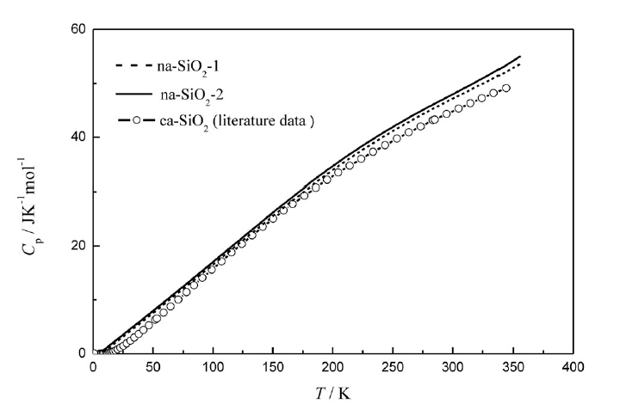

Reactor Kinetics:

To regress our kinetics, we made a random number generator code. We set a random number within a pre-determined range for the frequency factor and the activation energy for each of the forty reactions. Then, we ran the reactor at 490 C, 520 C, and 550 C. We took the overall splits of heavy cycle oil, light cycle oil, gasoline, light petroleum gas, dry gas, and coke and compared them to literature values. We took the sum of square error for each group at each temperature and got a total sum of square error for that set of kinetics. Then we randomly picked new kinetic values and started over. After the total sum of square error became less than 100, we manually changed the kinetic values to lower the total sum of square error. We were able to reach optimal kinetics that followed the trends of each group over the range of temperatures with a total sum of square of nineteen. With these kinetics, heavy cycle oil reduce as temperature rises, light cycle oil reduces to a point then flattens out, gasoline remains mostly constant, light petroleum gases and dry gases increase with temperature, and coke increases slowly with temperature.

Table 2: Reactor Reactions and Kinetic Data

|  |  |  |  |
| --- | --- | --- | --- |
| Reaction | Reaction Number | Frequency Factor | Activation Energy |
| Nonacosane -> Eicosane + Octene + Coke | 1 | 1425 | 13650 |
| Nonacosane -> Octadecane + Decene + Coke | 2 | 1425 | 13650 |
| Hexacosane -> Eicosane + Pentene + Coke | 3 | 1400 | 13650 |
| Hexacosane -> Pentadecane + Decene + Coke | 4 | 1425 | 13650 |
| Uneicosane -> Decane + Decene + Coke | 5 | 1425 | 13650 |
| Uneicosane -> Cetane + Butene+ Coke | 6 | 1425 | 13650 |
| Eicosane -> Pentadecane + Pentene | 7 | 1425 | 13650 |
| Eicosane -> Decane + Decene | 8 | 1425 | 13600 |
| N-Pentadecylbenzene -> Benzene + Pentadecene | 9 | 2000 | 13650 |
| N-Pentadecylcylopentane -> Cyclopentane + Pentadecene | 10 | 1500 | 13650 |
| N-Pentadocylcyclopentane -> N-Dodecylcyclopentane + Propene | 11 | 1500 | 13650 |
| Octadecane -> Decane + Heptene + Coke | 12 | 1450 | 9000 |
| N-Dodecylcyclopentane -> Decene + Ethene + Cyclopentane | 13 | 1450 | 9000 |
| Cetane -> Decane + Pentene + Coke | 14 | 1450 | 9000 |
| Pentacdecane -> Decane + Pentene | 15 | 1450 | 9000 |
| Pentadecene -> Decene + Pentene | 16 | 1450 | 9000 |
| Phenylbenzene + Hydrogen -> 2 x Benzene | 17 | 2000 | 9000 |
| Decane -> Octane + Ethene | 18 | 700 | 10000 |
| Decane -> Petane + Pentene | 19 | 1000 | 9000 |
| Decene -> N-butylcyclohexane | 20 | 900 | 12000 |
| Decene -> Heptene + Propene | 21 | 1000 | 8900 |
| N-butylcyclohexane -> Octene + Ethene | 22 | 930 | 10000 |
| Octane -> Pentane + Propene | 23 | 1600 | 7900 |
| Octene -> Petene + Propene | 24 | 1600 | 7000 |
| Heptene -> Cycloheptane | 25 | 1600 | 8100 |
| Heptene -> Butene + Propene | 26 | 2020 | 7950 |
| Cycloheptane -> Butene + Propene | 27 | 1100 | 6000 |
| Pentane -> Butene + Methane | 28 | 1000 | 6000 |
| Pentene -> Cyclopentane | 29 | 1000 | 6000 |
| Pentene -> Propene + Ethene | 30 | 1560 | 8000 |
| Pentene + Hydrogen -> Pentane | 31 | 900 | 9000 |
| Cyclopentane -> Ethene + Propene | 32 | 50 | 9000 |
| Butane -> Ethane + Ethene | 33 | 10 | 10000 |
| Butene -> 2 x Ethene | 34 | 100 | 10000 |
| Butene + Hydrogen -> Butane | 35 | 20000 | 10000 |
| Propane -> Ethene + Methane | 36 | 100 | 10000 |
| Propene + Hydrogen -> Propane | 37 | 20000 | 10000 |
| Ethene + Hydrogen -> Ethane | 38 | 20000 | 10000 |
| Ethene -> Coke | 39 | 1000 | 5000 |
| Methane -> Coke | 40 | 1000 | 5000 |

Table 3: Literature Data used for regressing Kinetics [17]

|  |  |  |  |  |  |  |  |
| --- | --- | --- | --- | --- | --- | --- | --- |
| Temp (C) | Conversion | GSLN | LPG | Dry Gas | LCO | HCO | Coke |
| deg C | % (wt) | % (wt) | % (wt) | % (wt) | % (wt) | % (wt) | % (wt) |
| 510 | 69.24 | 45.03 | 17.43 | 3.24 | 21.38 | 9.34 | 3.54 |
| 520 | 73.13 | 45.37 | 20.06 | 3.9 | 19.01 | 8.06 | 3.8 |
| 530 | 74.11 | 44.79 | 20.9 | 4.44 | 18 | 8.01 | 3.98 |
| 540 | 74.77 | 42.89 | 21.86 | 5.67 | 18.03 | 7.24 | 4.35 |

Table 4: Literature Data used for regressing Kinetics [17]

|  |  |
| --- | --- |
|  | Feed Stock |
|  | % (wt) |
| Parffins | 62.53 |
| Aromatics | 15.45 |
| Naphthalenes | 22.02 |

Table 5: Sum of Square Error for Regressed Data



Figure 5: FCC Model Residence Time Vs Mass Fraction of Products

Figure 6: FCC Reactor Temperature Time Vs Mass Fraction of Products

Reactions:

Our reactions were a means to an end to get our products, which were previously justified. The goal was to get the expected products while keeping the reactor as simple as possible. We had the heavy cycle oil break down into the light cycle oil and gasoline. Then we had the light cycle oil break down into gasoline, light petroleum gases, and fuel gases. Our gasoline will break down into light petroleum gases and fuel gases. In the light petroleum gas and fuel gas, the olefins will undergo hydrogenation to become paraffins, and break down into coke. The reactions follow a pathway to where, if left alone long enough the reactor would break everything down into coke eventually. There were no dead ends in the reactions pathways except for benzene which would not break down at any reliable speed due to the strength of the aromatic ring. [3,4,11]

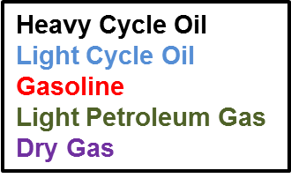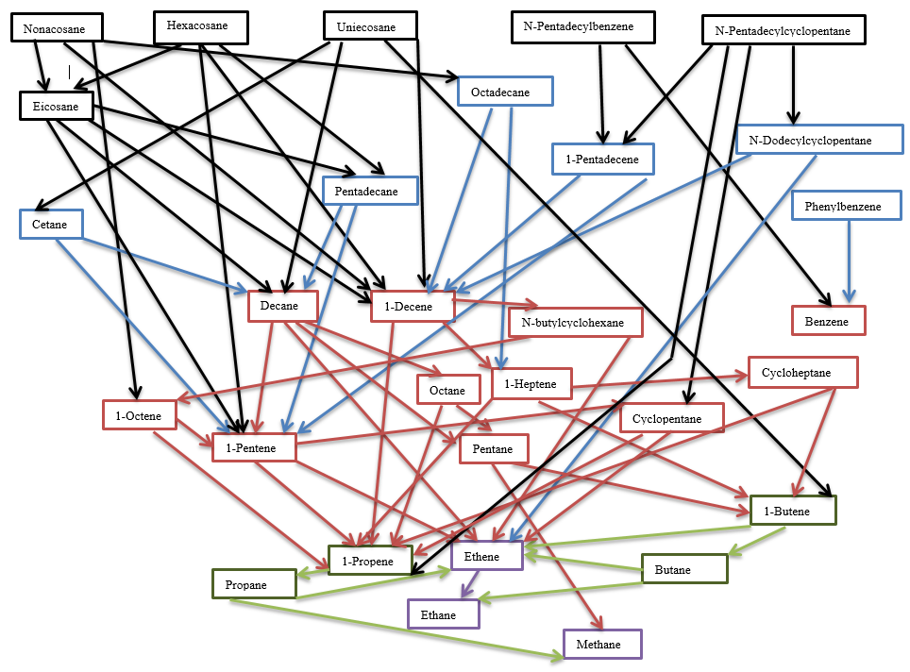

*A3. Regenerator*

Our regenerator was set to only do incomplete combustion as specified in class. It was modeled in ChemCAD as a stoichiometric reactor to make carbon monoxide. Our sizing was based off of the residence time of the regenerator. It was stated in reference 21 that the residence time used there was 156 hours. This is a reasonable residence time. We took the volumetric flowrate into the regenerator and found our volume to be 14.5 meters cubed.

*A4. FCC Reactor Sizing*

The FCC was sized in three components: the riser, the regenerator, and the catalyst separator.

Reactor: Typical risers are 2 to 7 feet (61 to 213 cm) in diameter and 75 to 120 feet (23 to 37 meters) long. We sized the riser as process vessel.

Regenerator: The regenerator is sized as a process vessel and explained in the regenerator section.

Catalyst separator: The catalyst separator section is sized as a Cyclone separator. Based on the Washington.edu reference the Ergun equation is set equal to the gravitational force of the bed.

g*(ρs– ρ) = +

Above g is the gravitational acceleration, ρs is the catalyst density, ρ is the fluid density, u is the minimal fluidization velocity, dp is the particle diameter of the catalyst, is the viscosity of the fluid, and ε is the void fraction. In order to ensure that the bed is fluidized it is assumed that the velocity of the feed is 1.2 times the minimum required velocity. It is also assumed that 80% of the minimal velocity is necessary to disengage the catalyst from the stream. The volumetric flow rate into the cyclone can be pulled from ChemCad. The necessary entering area of the cyclone needed to maintain 1.2 times the minimal required velocity can be found by

V = Ac * 1.2u

V is the volumetric flow rate and Ac is the cross sectional area of the cyclone. The needed area at the end of the cyclone can be found using 80% of u and the following correlation

Acin * 1.2u= Acout * .8u

To find the volumetric flow rate of the cyclone needed for sizing is found by multiplying the average of the inlet and outlet areas and velocities.

9.81*(2240 – 6.48) = +

u = 0.23

Catalysts come in various sizes so .5mm was chosen and 0.45 was selected as the void fraction based on the article by Subramanian. From ChemCad the volumetric flow into the cyclone is 0.27 .

0.27 = Ac * 1.2*(0.23

Ac = 0.98 m2

The needed outlet area is

.98m2 * 1.2*(0.23 = Acout * .8*(0.23

ACout = 1.47

The needed volumetric flowrate is

V = *

V =0.282

*A5. Fractionator*

The fractionator portion of the FCC was simulated as three distillation columns. These columns split the reactor product into 4 cut fractions: gases, gasoline, LCO, and HCO. The gas cut fraction is composed of carbon compounds in the range of methane to butane. The gasoline fraction ranges from pentane to decane. The LCO fraction contains carbons in the range of phenylbenzene to octadecane. The HCO fraction composition ranges from n-pentadecylbenzene to nonacosane. The range of components for each split was based on literature and the number of components in each split was determined by comparing the reboiler duty and reflux ratio for various numbers of components in each split. The comparison was started at the two components closet in boiling points between the splits. Each split was tested at 75, 50, and 25 weight percent of one fraction, with the other fraction completing the mass balance. The analysis of the splits is seen in the figures below.

Figure 9: GSLN/LPG Number of Components Justification with Reboiler Duty

Figure 10: GSLN/LPG Number of Components Justification with Reflux Ratio

Figure 12: HCO/LCO Number of Components Justification with Reboiler Duty

Figure 13: HCO/LCO Number of Components Justification with Reflux Ratio

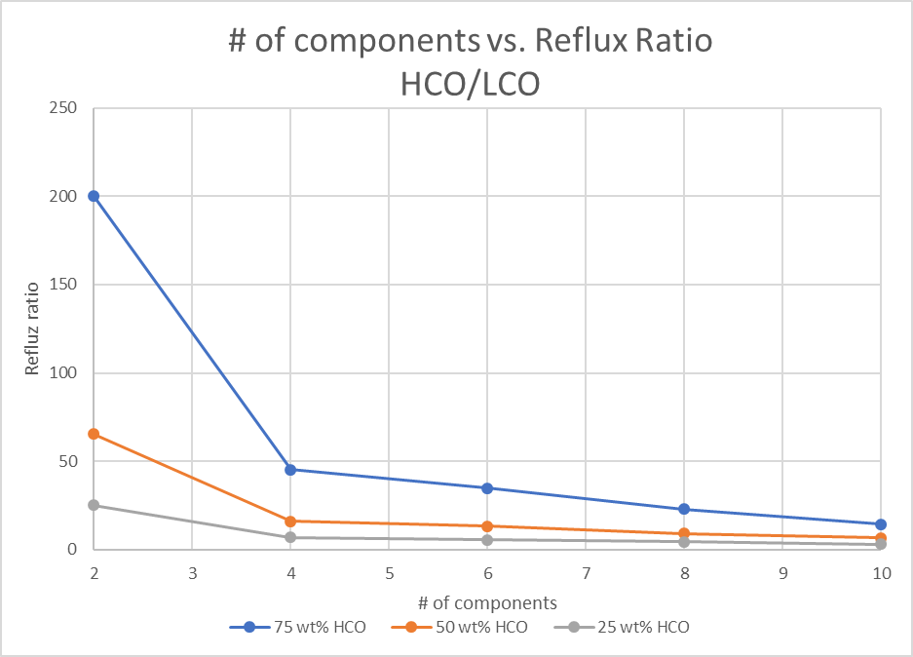

The feed from the reactor is fed into the main column. The main column produces two cut fractions. The top fraction is a combination of the dry gas and LPG fractions. The bottoms is composed mainly of HCO and is recycled back into the reactor. Two side streams are pulled off of the main tower. Each of these side streams is sent to a secondary distillation tower. These towers separate the feed into a desired cut fraction in one output and the other output is recycled back into the main distillation column. The main distillation column, tower 1, contains 45 total trays with a feed tray located at tray 35. The distillation tower used to separate the gasoline fraction, tower 3, is fed with a stream pulled from tray 3 of tower 1with a specification of a liquid draw ratio of 0.9. The distillation tower used to separate the LCO fraction, tower 3, is fed with a stream pulled from tray 44 of tower 1 with a specification of liquid draw ratio of 0.9. Tower 1 operates using a partial condenser and towers 2 and 3 both use a total condenser, 20 trays, and a feed at tray 15. The distillate stream of both towers 2 and 3 will be sold and the bottoms streams of both tower 2 and 3 will be recycled into tower 1 at tray locations of 3 and 45 respectively. The highest mole fraction of a component outside of the dry gas range is 0.02% cyclopentane. The purity of this stream is fine. In order to calculate the boiling point of our gasoline, LCO, and HCO cuts, the mole fraction of each component in the stream being analyzed was multiplied by its boiling point from table 1 from the appendix. and those totals were summed. The boiling point of the gasoline cut fraction is 32oC and the reference boiling point range is 35 to 220oC. The boiling point of the LCO is 215oC and the reference range from the FCC Handbook is 224 to 582oC. Both of these boiling points are slightly below the reference range, but at the writing of this report the boiling points are essentially the lowest temperature of the range. This is considered an acceptable cut fraction. The boiling point of the HCO cut is 302oC and the boiling point range of HCO is similar to VGO and is 315 to 595oC. Currently 20% of the HCO fraction is being recycled back into the reactor. The amount of recycle is a possible optimization point moving forward. All cut fractions pulled from the fractionator unit are close to or within the reference boiling point ranges. The boiling point ranges were obtained form the FCC Handbook.

Table 5: Fractionator Product Purity [3,4]

|  |  |  |
| --- | --- | --- |
| Cut Fraction | Calculated Boiling Point | Reference Boiling Point Range |
| LPG/Dry Gas | -41oC | -53.68 – 30.2oC |
| Gasoline | 32oC | 35 – 220oC |
| LCO | 215oC | 224 – 582oC |
| HCO | 302oC | 315-595oC |

**B. Thermodynamic Equation of State Justification**

Data on the full list of components used in a FCC system was not available. To get approximate data to compare with the equations of state, Pentane-Propane, Pentane-Heptane, and Butane-Heptane systems were examined. In the Pentane-Heptane and Butane-Heptane systems, the Peng Robinson equation of state best represented the experimental data with the SRK equation of state as the second best. The SRK equation of state best represented the Pentane-Propane system. Since the Peng Robinson equation of state worked best for most of the systems and worked well for the other, the simulation will be run using the Peng Robinson equation of state. The NRTL, the SRK, the UNIFAC, the UNIQUAC, the Van Laar, the Wilson, and the Peng Robinson equations of state were all compared to the experimental data using the Sum of Least Squares method.

Figure #: Pentane-Propane VLE Data

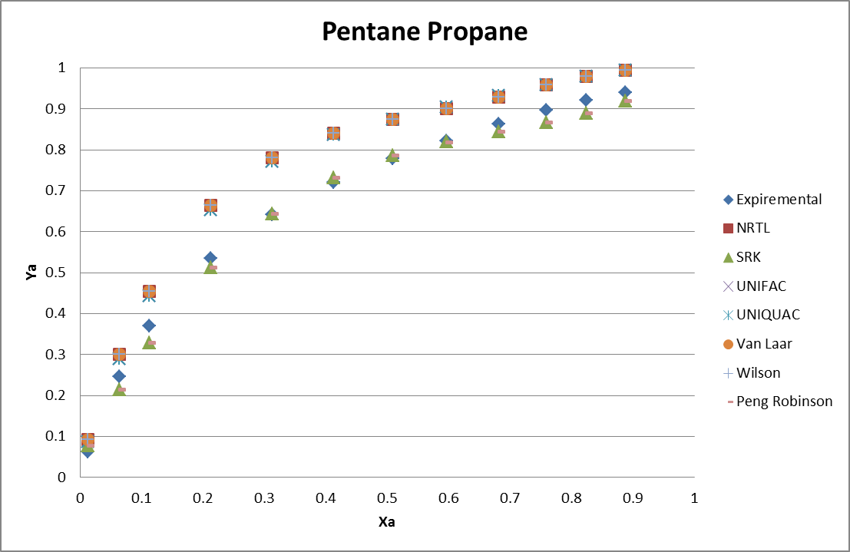

Figure7: Pentane-Heptane VLE Data

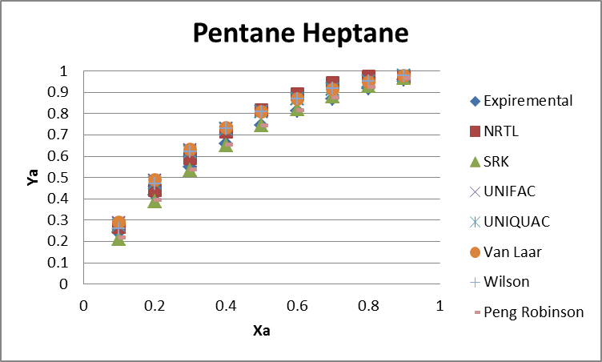

Figure8: Butane-Heptane VLE Data

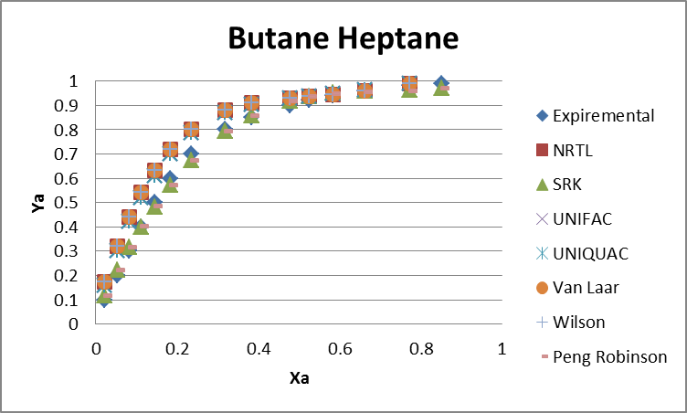

**C. Safety Considerations**

No safety measures have been sized or costed to implement into the base case. However, thought has been put into safety measures that will be added in the future. Flares will be needed for all three of the distillation columns in order to account for the possibility of the level of the columns rising uncontrolled. The flairs prevent the buildup of flammable gases that may lead to explosions. The cracking reaction is endothermic. In the event that the residence time of the reactor were not able to be controlled, the temperature of the reactor could continually decrease. This temperature drop could in turn lower the pressure inside the reactor. Since the reactor is ran at atmospheric pressure, a pressure drop would create a vacuum. If this vacuum became too profound the reactor could implode. In order to account for the possible vacuum a pressure relief valve may be worth implementing in the reactor.

Table A1: Boiling Points of Each Product Component

|  |  |  |  |  |  |
| --- | --- | --- | --- | --- | --- |
| Component Name | CAS Number | Chemical Formula | Molecular Weight | Boiling Pt (F) | Lump Equivalent |
| Nonacosane | 630-03-5 | C29H60 | 408.8 | 825.5 | Heavy Cycle Oil |
| Hexacosane | 630-01-3 | C26H54 | 366.7 | 788 | Heavy Cycle Oil |
| N-Pentadecylbenzene | 2131-18-2 | C21H36 | 288.51 | 701.6 | Heavy Cycle Oil |
| N-Pentadecylcyclopentane | 6006-95-7 | C20H40 | 280.53 | 680.2 | Heavy Cycle Oil |
| Uneicosane | 629-94-7 | C21H44 | 296.58 | 673.7 | Heavy Cycle Oil |
| Eicosane | 112-95-8 | C20H42 | 282.5475 | 648.9 | Heavy Cycle Oil |
| Octadecane | 593-45-3 | C18H38 | 254.5 | 601 | Light Cycle Oil |
| N-Dodecylcyclopentane | 5634-30-0 | C17H34 | 238.45 | 593.4 | Light Cycle Oil |
| Cetane | 544-76-3 | C16H34 | 226.45 | 548.2 | Light Cycle Oil |
| Pentadecane | 629-62-9 | C15H32 | 212.421 | 519.1 | Light Cycle Oil |
| Pentadecene | 13360-61-7 | C15H30 | 210.41 | 515.3 | Light Cycle Oil |
| Phenylbenzene | 92-52-4 | C12H10 | 154.21 | 489 | Light Cycle Oil |
| N-Butylcyclohexane | 1678-93-9 | C10H20 | 140.27 | 356 | Gasoline |
| Decane | 124-18-5 | C10H22 | 142.29 | 345.4 | Gasoline |
| 1-Decene | 872-05-9 | C10H20 | 140.27 | 339.1 | Gasoline |
| Octane | 111-65-9 | C8H18 | 114.23 | 257 | Gasoline |
| 1-Octene | 111-66-0 | C8H16 | 112.24 | 249.8 | Gasoline |
| Cycloheptene | 291-64-5 | C7H14 | 96.17 | 238.5 | Gasoline |
| 1-Heptene | 592-76-7 | C7H14 | 98.19 | 201.2 | Gasoline |
| Benzene | 71-43-2 | C6H6 | 78.11 | 176.2 | Gasoline |
| Cyclopentane | 287-92-3 | C5H10 | 70.1 | 120.2 | Gasoline |
| Pentane | 109-66-0 | C5H12 | 72.15 | 96.98 | Gasoline |
| 1-Pentene | 109-67-1 | C5H10 | 70.135 | 86 | Gasoline |
| Butane | 106-97-8 | C4H10 | 58.12 | 30.2 | Light Petroleum Gas |
| 1-Butene | 106-98-9 | C4H8 | 56.108 | 20.66 | Light Petroleum Gas |
| Propane | 74-98-6 | C3H8 | 44.1 | -43.6 | Light Petroleum Gas |
| 1-Propene | 115-07-1 | C3H6 | 42.08 | -53.68 | Light Petroleum Gas |
| Ethane | 74-84-0 | C2H6 | 30.07 | -128.2 | Fuel Gas |
| Ethene | 74-85-1 | C2H4 | 28.05 | -154.7 | Fuel Gas |
| Methane | 74-82-8 | CH4 | 16.04 | -258.7 | Fuel Gas |

**C. Cost Analysist**

The net present value for each case was found assuming a15 year project life, 7 year MACRS depreciation, a 32% tax rate, and 16% interest rate. Pump utilities were negligible and ignored and all equipment was priced according to *Turton, R*.

1. **Process Equipment Sizing Method**

|  |  |
| --- | --- |
| Equipment Name: T-101 | Sizing information:  Tray Efficiency  Tower Height |
| Equipment Type: Distillation Tower |
| Relevant Information: Seive Tray Tower, 47 trays, Feed Stream Enters at 13 Stages, Column Diameter 3 ft., Tray Spacing 2 ft., Tower Height 94 ft Tray Efficiency 68.97% |
| Reference Information: Drickamer-Bradford Empirical Correlation |

T-101, Distillation Tower: The diameter of the tower was found using Chemcad. The tray efficiency was found using the Drickamer-Bradford empirical correlation, which intern lead to the actual number of trays. The height of the tower was determined by multiplying the tray height by the actual number of trays.

|  |  |
| --- | --- |
| Equipment Name: T-102 | Sizing information:  Tray Efficiency  Tower Height |
| Equipment Type: Distillation Tower |
| Relevant Information: Seive Tray Tower,48 trays, Feed Stream Enters at 17 Stages, Column Diameter 3 ft., Tray Spacing 2 ft., Tower Height 96 ft Tray Efficiency 68.822% |
| Reference Information: Drickamer-Bradford Empirical Correlation |

T-101, Distillation Tower: Calculations are the same as T-101.

|  |  |
| --- | --- |
| Equipment Name: V-101 | Sizing information:  Tank should hold 5 min process time at half volume. |
| Equipment Type: Reflux/ Surge Tank |
| Relevant Information: Horizontal Pressure Vessel, Tank volume 67.6 ft3 |
| Reference Information: [4 Table 11.6, P344]] |

V-101, Reflux Tank: The reflux tank was sized to be able to hold a maximum of 10 min of distillate process flow.

|  |  |
| --- | --- |
| Equipment Name: V-102 | Sizing information:  Tank should hold 5 min process time at half volume. |
| Equipment Type: Reflux/ Surge Tank |
| Relevant Information: Horizontal Pressure Vessel, Tank volume 83.4 ft3 |
| Reference Information: [4, Table 11.6, P344] |

V-102, Reflux Tank: The reflux tank was sized to be able to hold a maximum of 10 min of distillate process flow. Calculations are the same as V-101.

|  |  |
| --- | --- |
| Equipment Name: E-101 | Sizing information: |
| Equipment Type: Condenser, Fixed Tube HX |
| Relevant Information: Utility Stream Refrigerated Water 41°F, Duty 2.29 MMBtu/hr., Reflux Ratio 0.636,  Area 1353.4 ft2 |
| Reference Information:  U=150 [4] |

E-1, Condenser: The area needed for the heat exchanger was found using . An average U value for a reboiler of U=150 was used and the Q equaled the duty of the condenser. Refrigerated water of 41 was used, and exited at 59

°F

A= 1353.4 ft2

|  |  |
| --- | --- |
| Equipment Name: E-103 | Sizing information: |
| Equipment Type: Condenser, Fixed Tube HX |
| Relevant Information: Utility Stream Cooling Water 86°F, Duty 2.43 MMBtu/hr., Area 180.6 ft2 |
| Reference Information:  U=150 [4] |

E-103, Condenser: The area needed for the heat exchanger was found using . An average U value for a reboiler of U=150 was used and the Q equaled the duty of the condenser. Cooling water of 86 was used, and exited at 108.5 Calculations are the same as E-101.

|  |  |
| --- | --- |
| Equipment Name: E-102 | Sizing information: |
| Equipment Type: Boiler, Floating Head HX |
| Relevant Information: Utility Stream Low Pressure Steam (5 Barg, 320°F), Duty 2.53 MMBtu/hr.,  Area 124.4 ft3 |
| Reference Information:  U=1140 [4] |

E-102, Reboiler: The area needed for the reboiler was found using the same method as the condenser. The average U value of 1140 was used and a low pressure steam, 5 Garg and 320°Fwas used as the heating source. Calculations are the same as E-101.

|  |  |
| --- | --- |
| Equipment Name: E-104 | Sizing information: |
| Equipment Type: Boiler, Floating Head HX |
| Relevant Information: Utility Stream Low Pressure Steam (5 Barg, 320°F), Duty 2.5 MMBtu/hr.,  Area 207.2 ft3 |
| Reference Information:  U=1140 [4] |

E-104, Reboiler: The area needed for the reboiler was found using the same method as the condenser. The average U value of 1140 was used and a low pressure steam, 5 Garg and 320°Fwas used as the heating source. Calculations are the same as E-101.

|  |  |
| --- | --- |
| Equipment Name: P-101,102,103,104 | Sizing information: |
| Equipment Type: Pump, Centrifugal |
| Relevant Information: Pump Efficiency 40%  P-101 0.1127 HP, P-103 0.0093 HP  P-102 0.011 HP, P-104 0.0088 HP |
| Reference Information:  [4,Table 11.9, pg 346] |

P-101, 102, 103, 104 Pumps: Pumps were all calculated the same. It is assumed that there is less than 100 ft of piping at the top of the tower and the distillate stream is run to a storage tank no more than 200 ft away. The pumps were sized using a 40% efficiency.

**E. Pricing**

Graph E1: FCC Costs

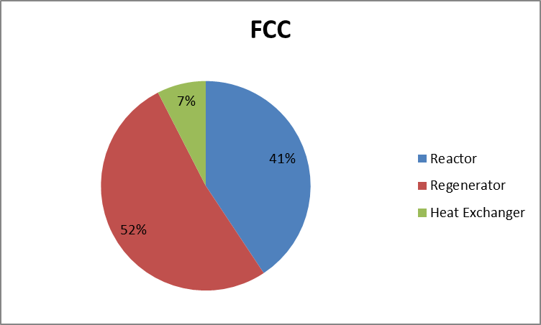

Table E1: FCC Costs

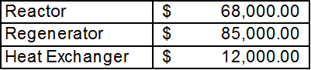

Graph E2: Fractionator Costs

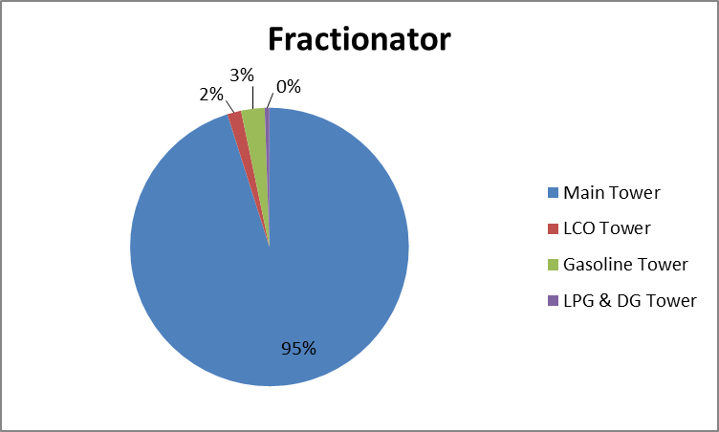

Table E2: Fractionator Costs

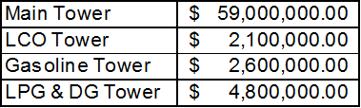

Graph E3: Main Tower Costs

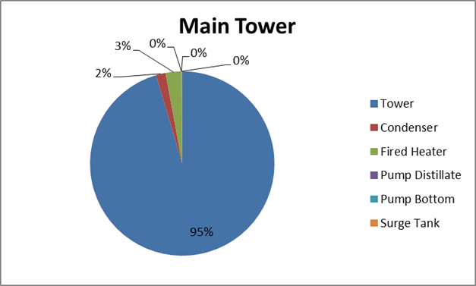

Table E3: Main Tower Costs

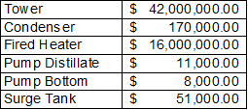

Graph E4: Light Cycle Oil Tower Costs

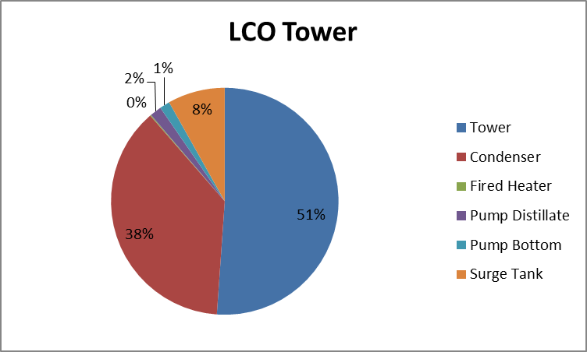

Table E4: Light Cycle Oil Tower Costs

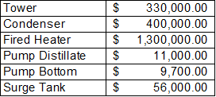

Graph E5: Gasoline Tower Costs

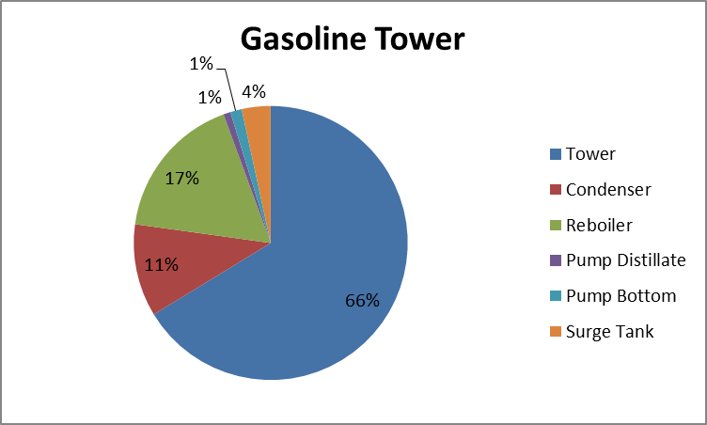

Table E5: Gasoline Tower Costs

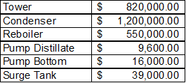

Graph E6: Light Petroleum Gas and Dry Gas Tower Costs

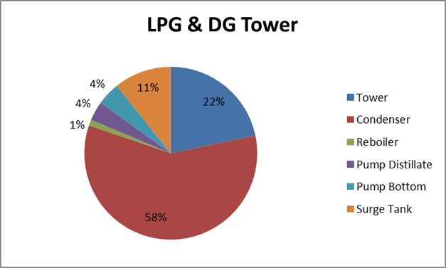

Table E6: Light Petroleum Gas and Dry Gas Tower Costs

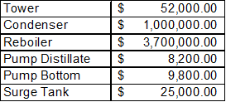

Graph E7: Total Utility Costs

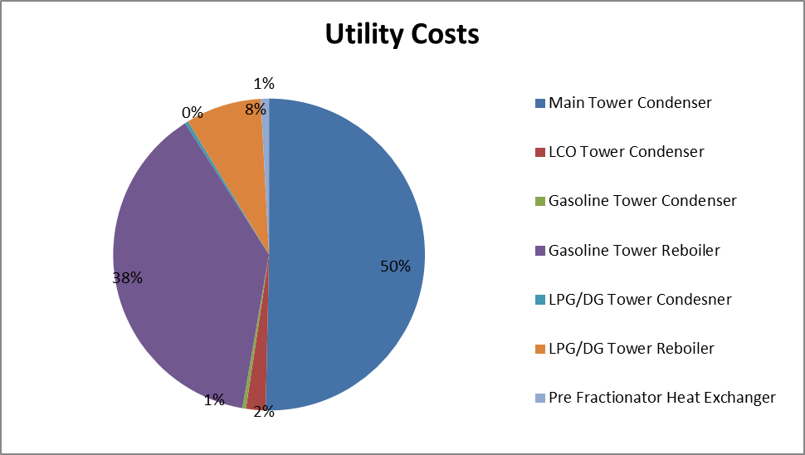

Table E7: Total Utility Costs

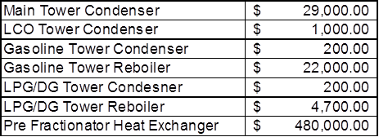

The fired heaters will be powered by the hydrogen removed from the dry gas stream. That amount of hydrogen should be able to produce 143 MMBtu, and the fired heaters require 81 MMBtu.

To test the sensitivity of our net present value, we changed the price per pound of each component by twenty or forty percent and tested the percent change of the net present value.

Graph E8: Net Present Value Sensitivity

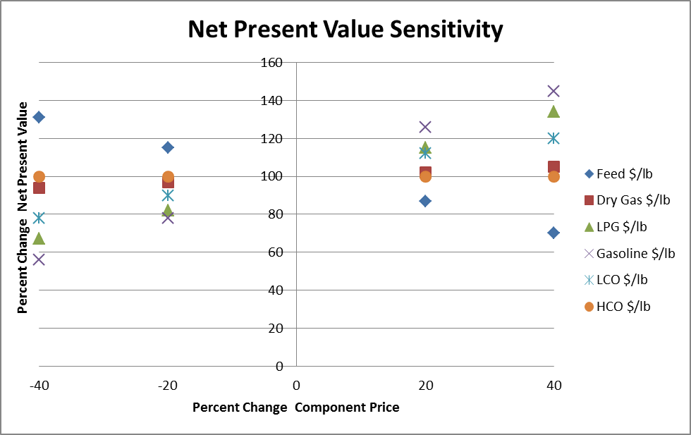

It was found that changing the cost of the feed and the sale value of gasoline will change the net present value the most. This is to be expected as the feed cost is the major cost, and gasoline is the major money maker.

To ensure the best pricing for our components were correct we researched multiple sources for our prices and compared the prices of gasoline, light petroleum gas, light cycle oil, and heavy cycle oil since 2012.

Table E8: Pricing Research

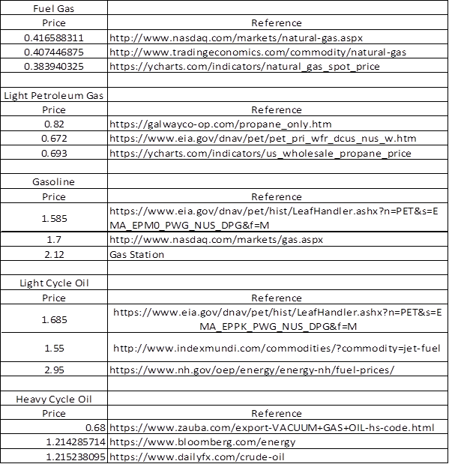

Graph E9: Component Prices 2012 to 2017

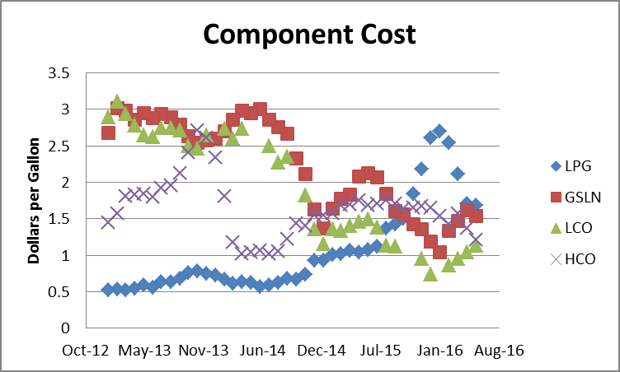

**F. Optimization**

To begin our optimization, we first optimized the riser for gasoline production. We set the riser volume at four specific residence times and increased the recycle rate to observe the effects that increasing the recycle rate had on the production of our different components.

Graph F1: Gasoline Production vs Reactor Volume

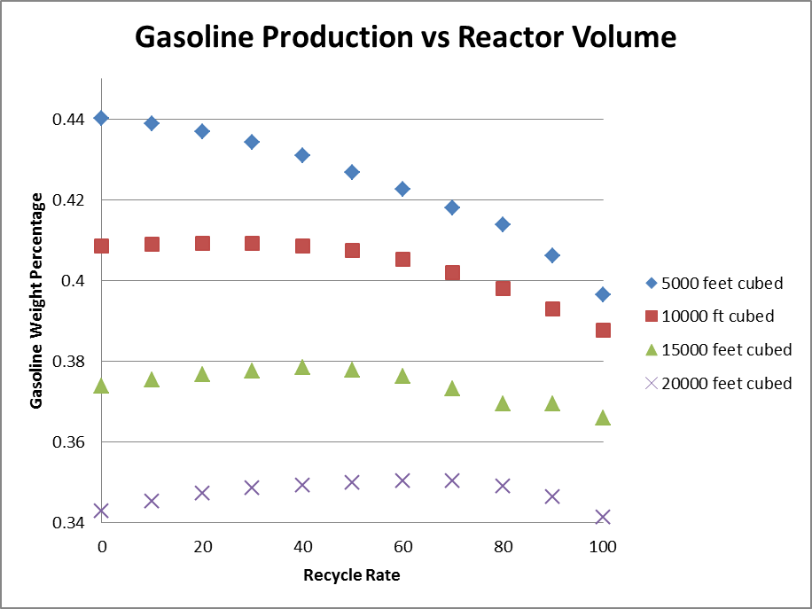

Graph F2: 5000 ft3 Riser Optimization

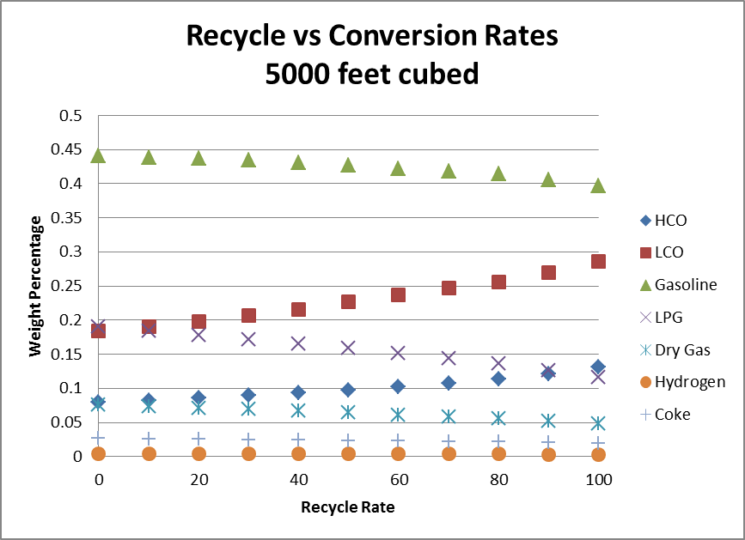

Graph F3: 10000 ft3 Riser Optimization

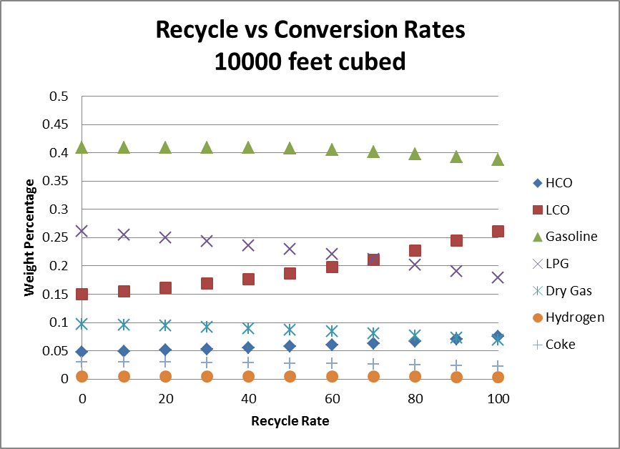

Graph F4: 150000 ft3 Riser Optimization

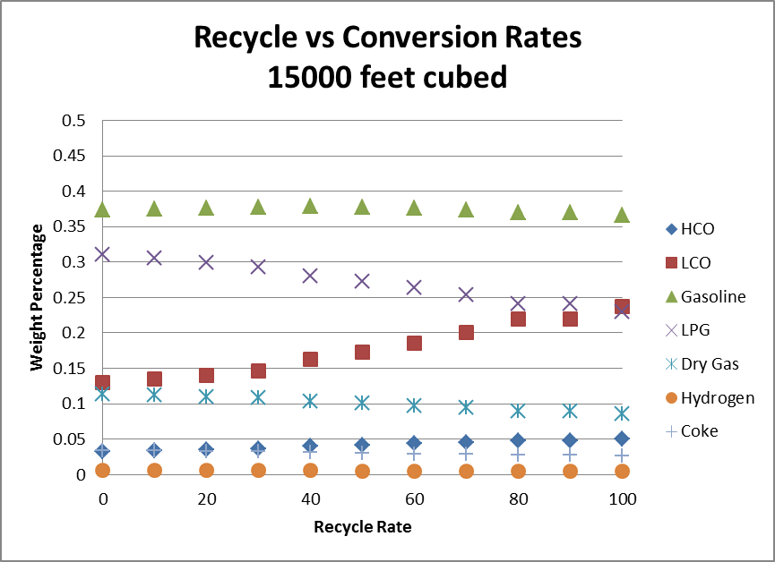

Graph F5: 200000 ft3 Riser Optimization

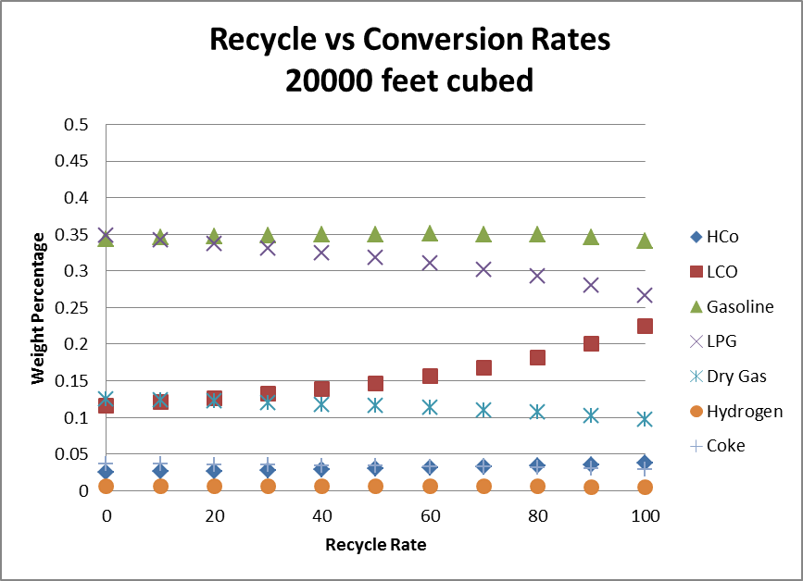

The results of this test showed that as we increased our recycle rate, gasoline, light petroleum gas and dry gas production fell, while light cycle oil and heavy cycle oil production rose. This makes sense because as recycle rate increases, our residence time decreases which means total cracking decreases. We also observed that as our set riser volume increases, our gasoline, light cycle oil, and heavy cycle oil production falls while our light petroleum gas, dry gas, and coke production rises. This matches the theory behind cracking. Our best riser volume was 5000 ft3. We did not test lower, because to test lower would mean going below the recommended minimum residence time that we discovered in literature. Additionally, when we tested at lower residence time, coke production was low enough that the regenerator did not produce enough heat through combustion to power the riser.

Next we optimized the towers. The goal of tower optimization was to lower the cost of the towers while maintaining the purities of the product streams. As each tower was reduced, each product stream would be tested to account for a minimum purity. If the streams were still reasonable pure, the tower was reduced again. When a tower could no longer produce the minimum required purity, the tower would be reverted to the size it last could, and the cost analysis began. From the minimum trays number the towers trays were increased to a tray number reasonably high enough to ensure that this point is not a local cost minimum. Feed tray location was also tested in each tower to find the optimal feed and height.

Graph F6: Main Tower Optimization

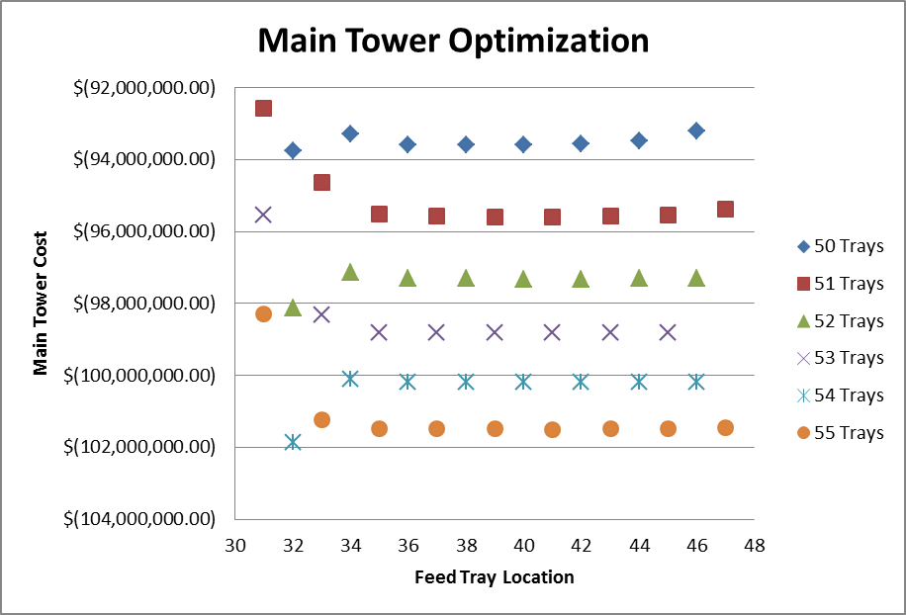

Graph F7: Light Cycle Oil Tower Optimization

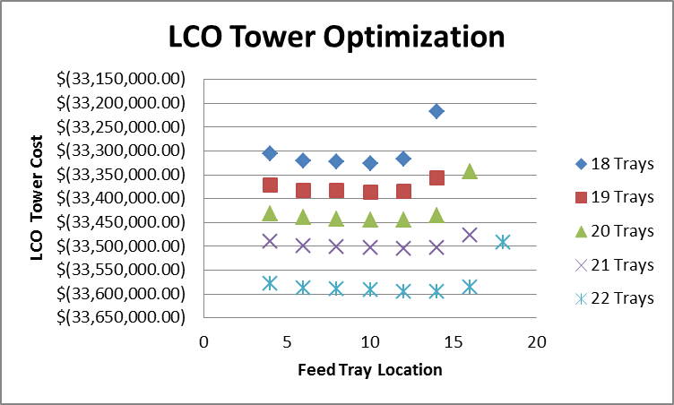

Graph F8: Gasoline Tower Optimization

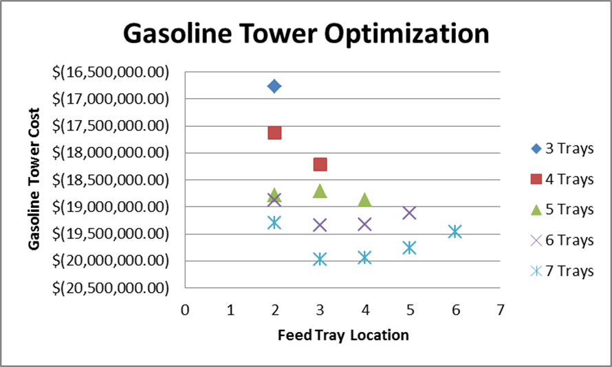

Graph F9: Light Petroleum Gas and Dry Gas Optimization Tower

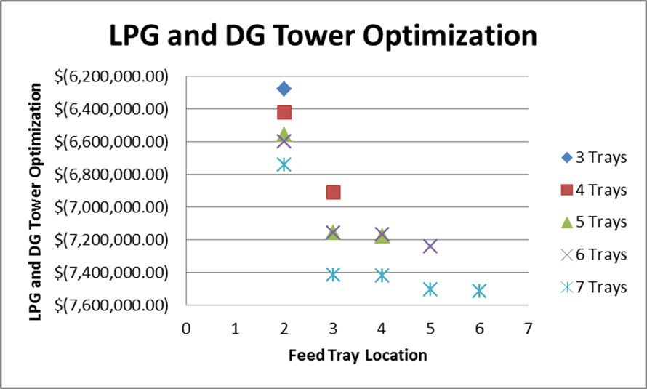

The gasoline and light petroleum gas/ dry gas towers were able to function at minimal trays. The main and light cycle oil towers had a minimum tray number dictated by purity. The tray numbers listed in the graphs above represent the theoretical number of trays in each tower and not the actual number.

Up until this point, our optimization has been focused on production and costs to specifically avoid the net present value calculations. This is to ensure that the FCC unit is built optimally for any set of prices and not just the current prices of our components. To finish optimization, full net present value had to be investigated though. To do complete our optimizations, the riser’s temperature, residence time, and recycle stream were tested to find the optimal point of operation.

Graph F10: Riser Optimization

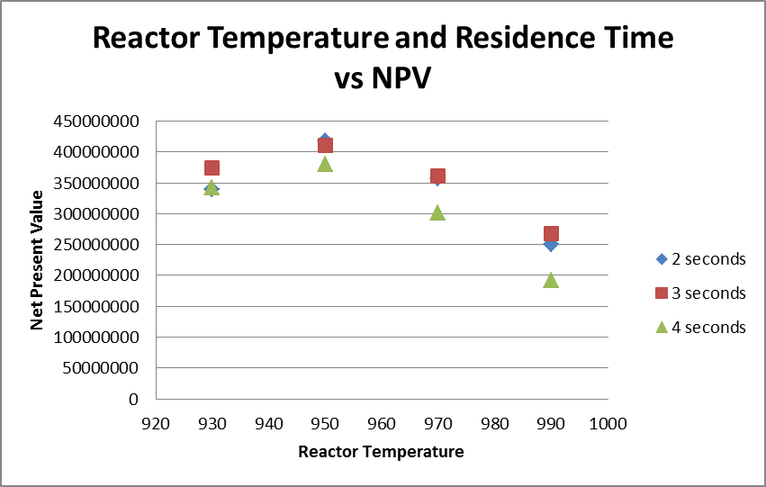

Graph F11: Riser Optimization



It was found that the optimal point of operation was at 2 seconds residence time (or 5000 ft3), 950 °F, and with a 100% recycle rate. Operating at these parameters yielded at net present value of $417 million dollars.

**G. Safety**

One of the first aspects of safety looked at was the overall P&ID. On the reactor and regenerator sections a differential pressure indicator was implemented between the two units in order to monitor possible backflow and operate a shutoff valve as necessary. The pressure in the regenerator will be controlled by the exiting flue gas flow rate. Level indicators were implemented on both units and the levels of both are controlled by catalyst leaving that unit. The temperature of the regenerator is controlled by the entering torch oil and air flow rates. The temperature of the reactor is controlled by the amount of catalyst entering from the regenerator. Catalyst to oil ratio is maintained by monitoring the reactant stream after the recycle has been mixed into the fresh feed.

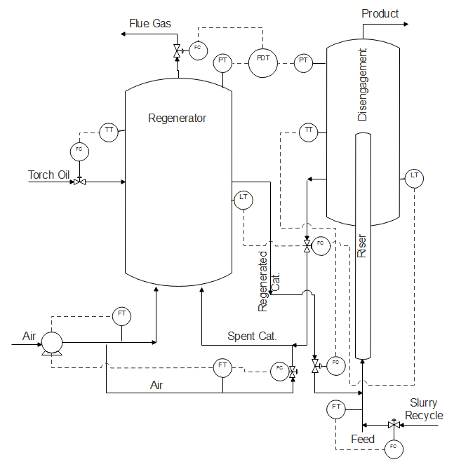 Figure G1 : P&ID of the Reactor and Regenerator

Basic control loops were implemented into the fractionator. Temperature controls on the top and bottom of the tower control the exchanger fluid flow rate. Level indicators control the outlet distillate flow to maintain level in the surge tank. Flow controls are used to maintain the reflux and boil up ratios.

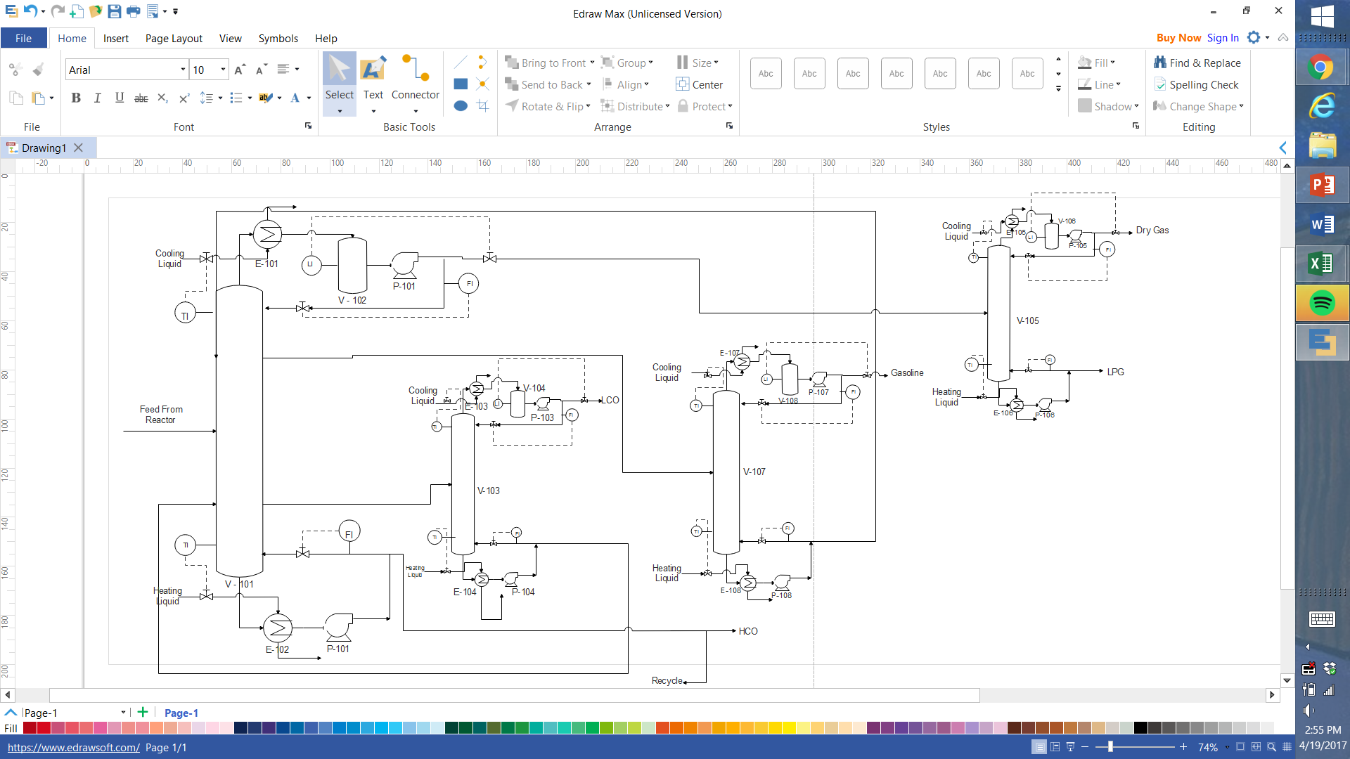 Figure G2 : Fractionator P&ID

Pressure relief valves were sized for the reactor and regenerator. The following equation was used for gases and rupture disks.

A = X = 519.5*

In the above equation Qm is the mass flow rate, Co is a constant, Kb is a back pressure correction factor, Pv is the max allowable pressure of the system, T is the temperature in Rankine, z is the compressibility factor, M is the molecular weight, and y is constant based on the gas used. The values for the reactor are as follows: Qm =52228 GPM, Co = 0.975, Kb = 1, Pv = 17.8 psi, X = 336.9, T = 1409 R, M = 68.26, y = 1.2. Giving a relief area of 37.3 in2 and a dimeter of 6.9 in. The values for the regenerator are as follows: Qm =12176 GPM, Co = 0.975, Kb = 1, Pv = 23.4 psi, X = 355.7, T = 1509 R, M = 31.41, y = 1.4. This gives an area of 10.4in2 and a diameter of 3.6in.

Finally calculations were made to determine the needed O2 concentration in the reactor for explosion. In order to calculate the lower flammability limit, LFL, and the upper flammability limit, UFL, the following equations and data was used.

LFL = UFL =

Table G1: LFL and UFL Calculations

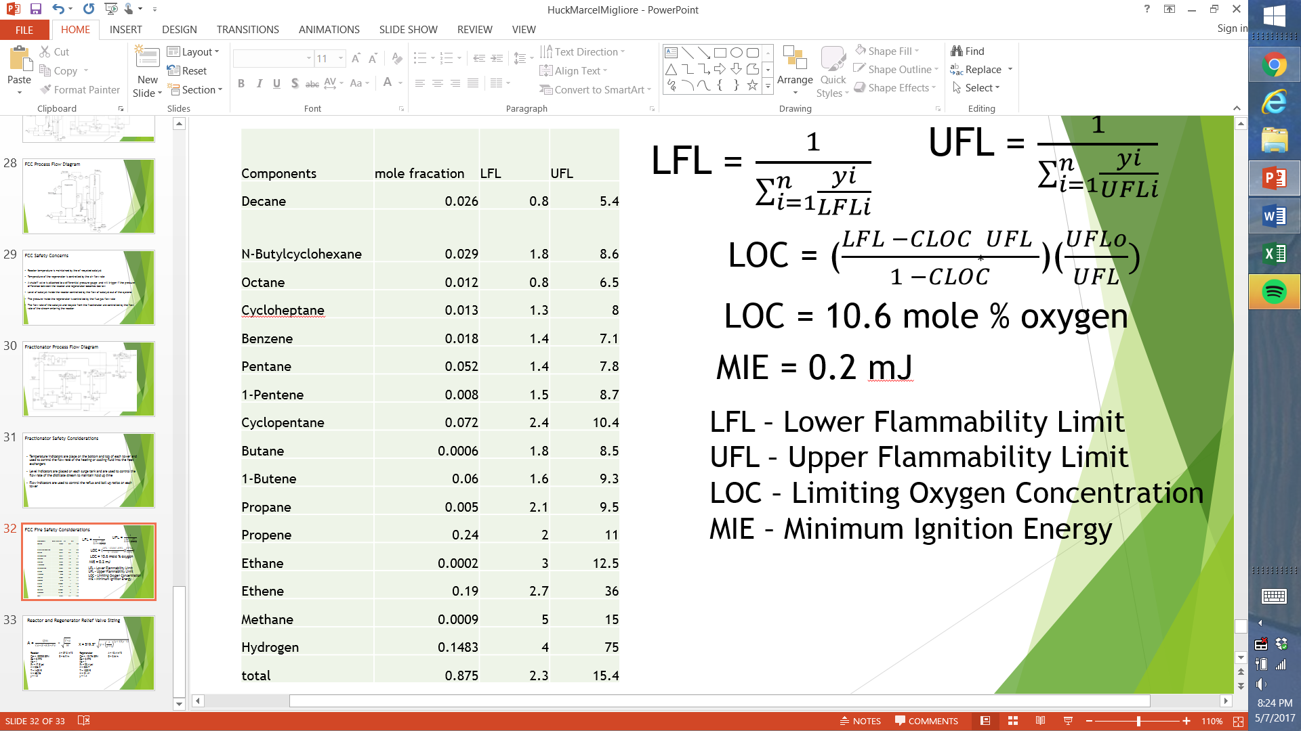

After this was calculated the following equation was used

LOC = ()(

With this equation the LOC was calculated as 10.6% mole oxygen.